Digital Logic and Computer Design Laboratory
3rd Semester, Academic Year 2026
Date:28-09-2026
Name: Yatin R | SRN:PES2UG25CS617 | Section: J

Week#8 Program Number:8
WRITE A VERILOG PROGRAM TO CONSTRUCT COMPARTOR AND PREFIX ADDER. GENERATE THE VVP OUTPUT AND SIMULATION WAVEFORM USING GTKWAVE. VERIFY THE OUTPUT AND WAVEFORM WITH THE TRUTH TABLE
- Verilog Code Screenshot
- Verilog VVP Output Screen Shot
- GTKWAVE Screenshot
- Output Table (Truth Table) to be completed and included

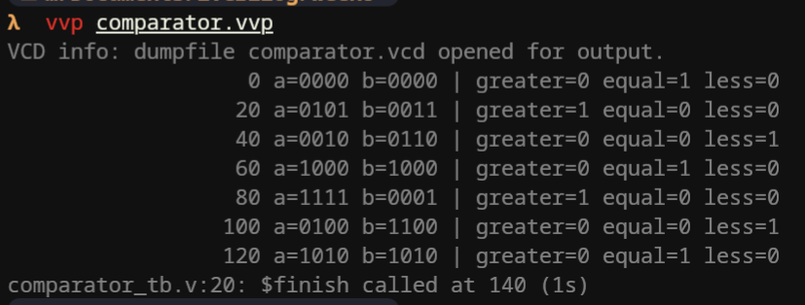
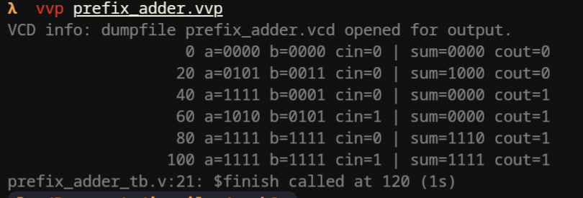
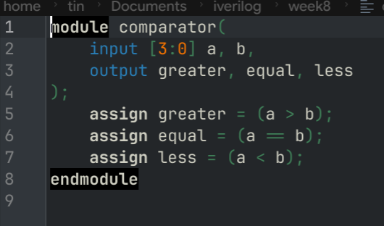
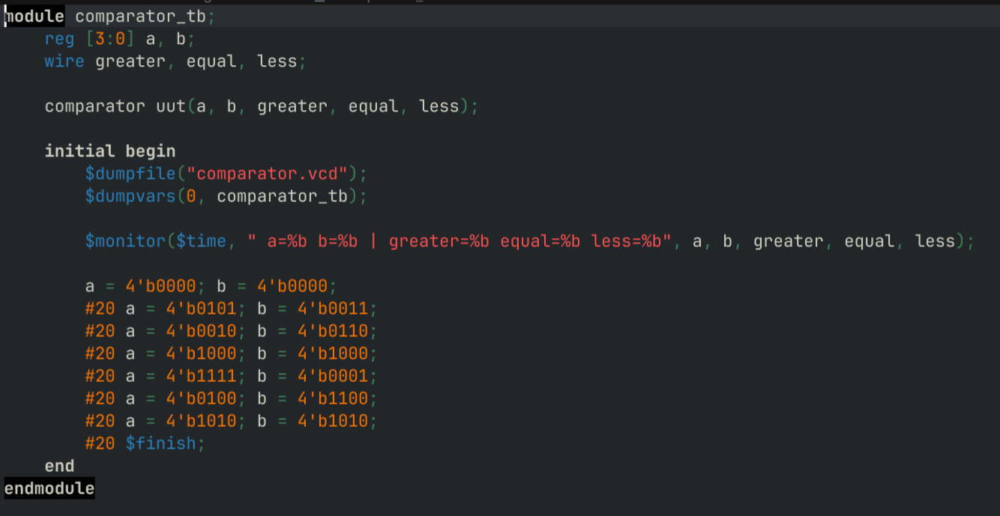
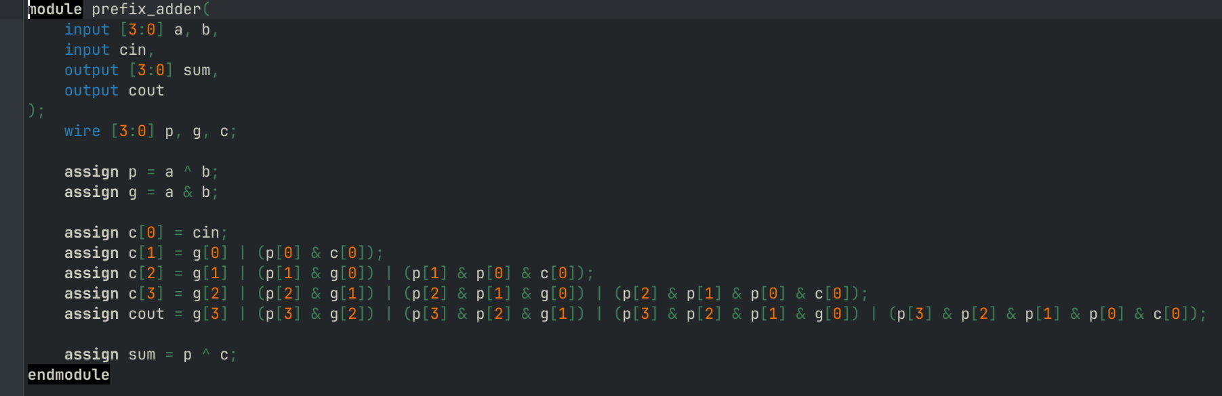

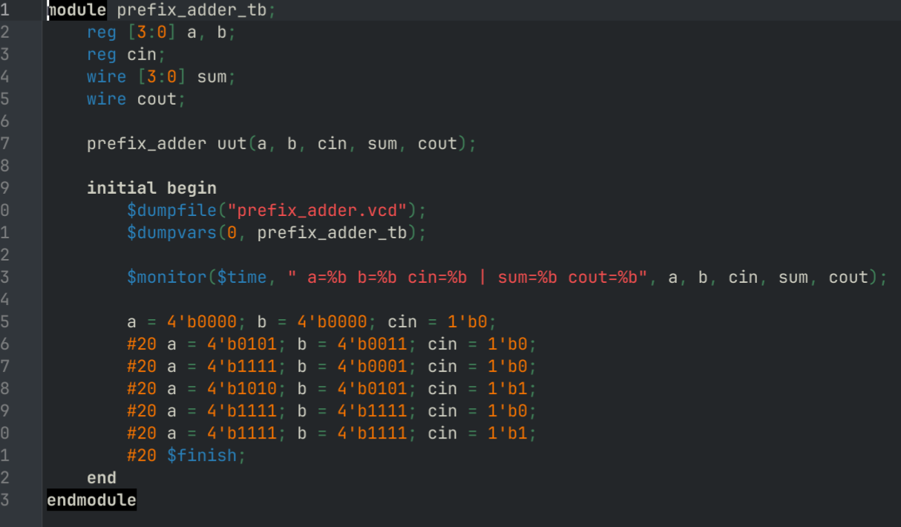
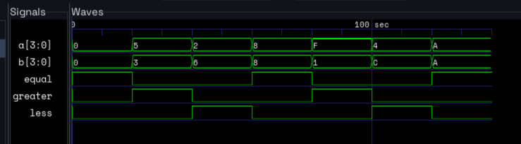
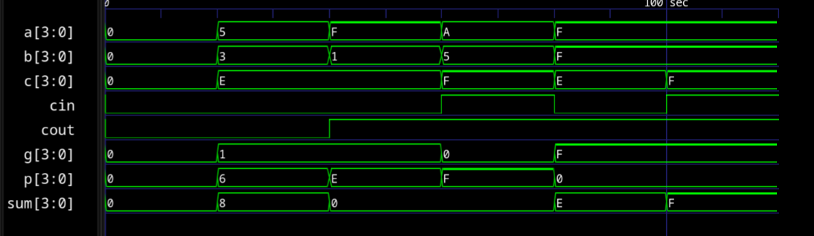

Table 1: 4-Bit Magnitude Comparator Verification Table
Test Case | A [3:0] (Binary) | A (Decimal) | B [3:0] (Binary) | B (Decimal) | Greater (A > B) | Equal (A = B) | Less (A < B)
1 | 0000 | 0 | 0000 | 0 | 0 | 1 | 0
2 | 0101 | 5 | 0011 | 3 | 1 | 0 | 0
3 | 0010 | 2 | 0110 | 6 | 0 | 0 | 1
4 | 1000 | 8 | 1000 | 8 | 0 | 1 | 0
5 | 1111 | 15 | 0001 | 1 | 1 | 0 | 0
6 | 0100 | 4 | 1100 | 12 | 0 | 0 | 1
7 | 1010 | 10 | 1010 | 10 | 0 | 1 | 0

Table 2: 4-Bit Prefix / Carry-Lookahead Adder Verification Table
Test Case | A [3:0] (Binary) | A (Dec) | B [3:0] (Binary) | B (Dec) | Cin | Sum [3:0] (Binary) | Sum (Dec) | Cout
1 | 0000 | 0 | 0000 | 0 | 0 | 0000 | 0 | 0
2 | 0101 | 5 | 0011 | 3 | 0 | 1000 | 8 | 0
3 | 1111 | 15 | 0001 | 1 | 0 | 0000 | 0 | 1
4 | 1010 | 10 | 0101 | 5 | 1 | 0000 | 0 | 1
5 | 1111 | 15 | 1111 | 15 | 0 | 1110 | 14 | 1
6 | 1111 | 15 | 1111 | 15 | 1 | 1111 | 15 | 1

If found plagiarized, I will abide with the disciplinary action of the University.
Signature: Yashwanth Karthik
Name: Yashwanth Karthik
SRN: PES2UG25CS615
Section: J
Date: 01/10/2026

